## Steps to connect two networks with a router

Step 1: create network like in the picture shown below

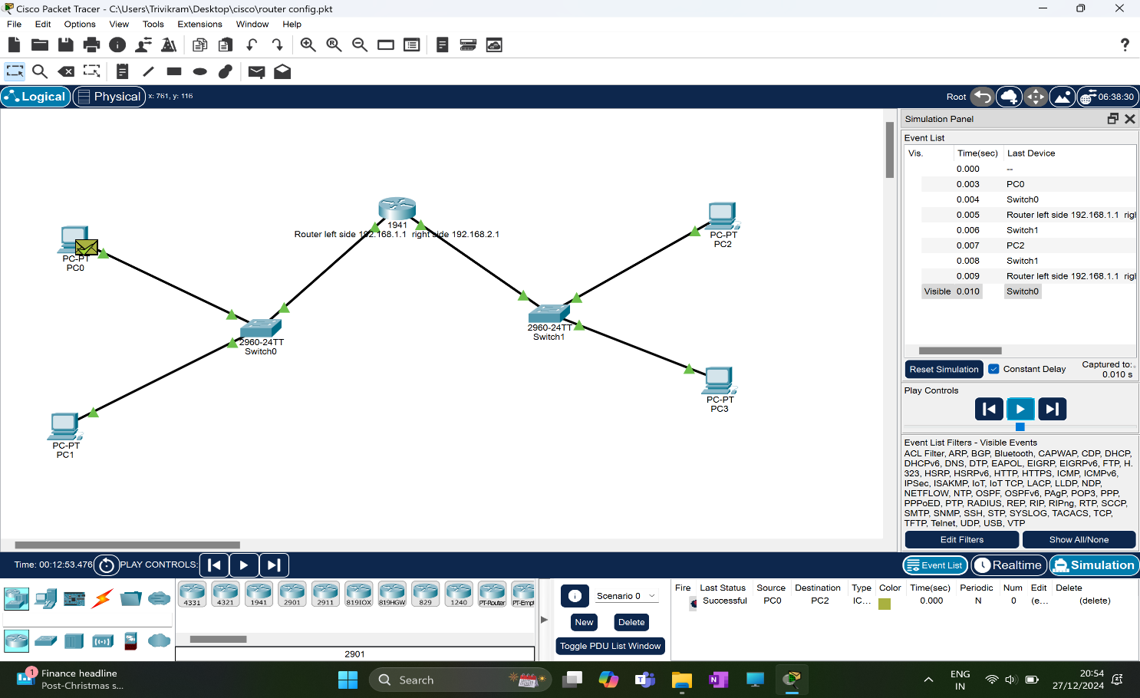

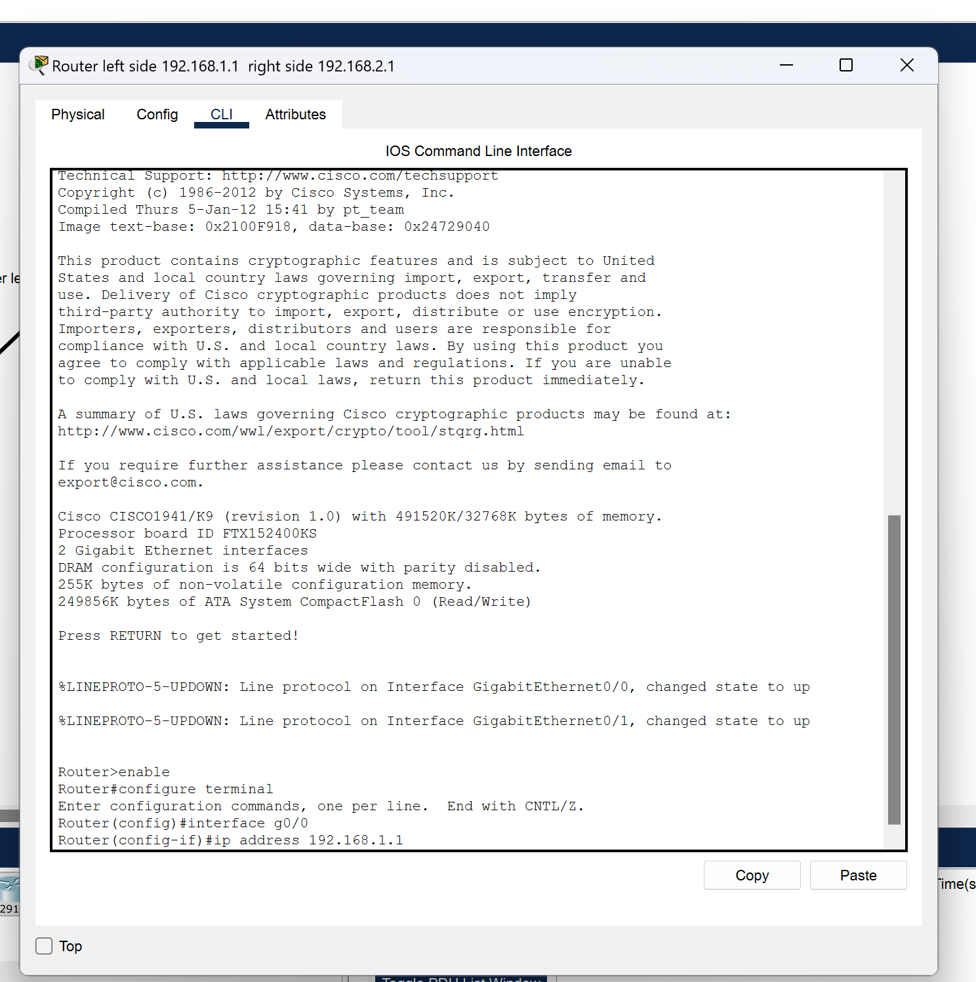



Step 2: configure the router as shown below

Enter the following commands in the CLI to configure router

1. enable
2. configure terminal
3. interface g0/0
4. ip address 192.168.1.1

now the connections are established

## Final result



## Observations

1. The router receives the packet from an incoming interface.
2. The router examines the packet's header, specifically focusing on the destination IP address.
3. The router consults its routing table to find the best route to the destination network. The routing table contains information about connected networks, learned routes from other routers, and statically configured routes.
4. Based on the routing table lookup, the router selects the appropriate outgoing interface to forward the packet.
5. The router forwards the packet to the selected outgoing interface

***Thank you***